LAB ASSIGNMENTS 5: AWS Lambda

What is AWS Lambda?

lets you run code without thinking about servers.

You pay only for the compute time that you consume —
there is no charge when your code is not running.
With Lambda, you can run code for virtually any type of application or backend service,
all with zero administration.

Serverless dont mean it dont have any server..Programmer is not responsable for managing and scaling. We want to deploy function that do some specific jobs

Funcation as a service

Limitation: function shoud not table more then 15min

Lambda can act as trigger for example let say when we upload an doc on aws s3 a function must run to process that file

AWS Lambda is a cloud computing service that lets developers run code without managing compute resources. It's an example of serverless architecture and function as a service (FaaS).

Example : create hello world lambda function

Step 1: create myfirstlambda
Step 2: check log group on cloud watch : no logs
Step 3: Create jar of hello world project and upload it
Step 4: edit runtime setting and change name of package and class and handler
Step 5: test it

Step 1: create myfirstlambda

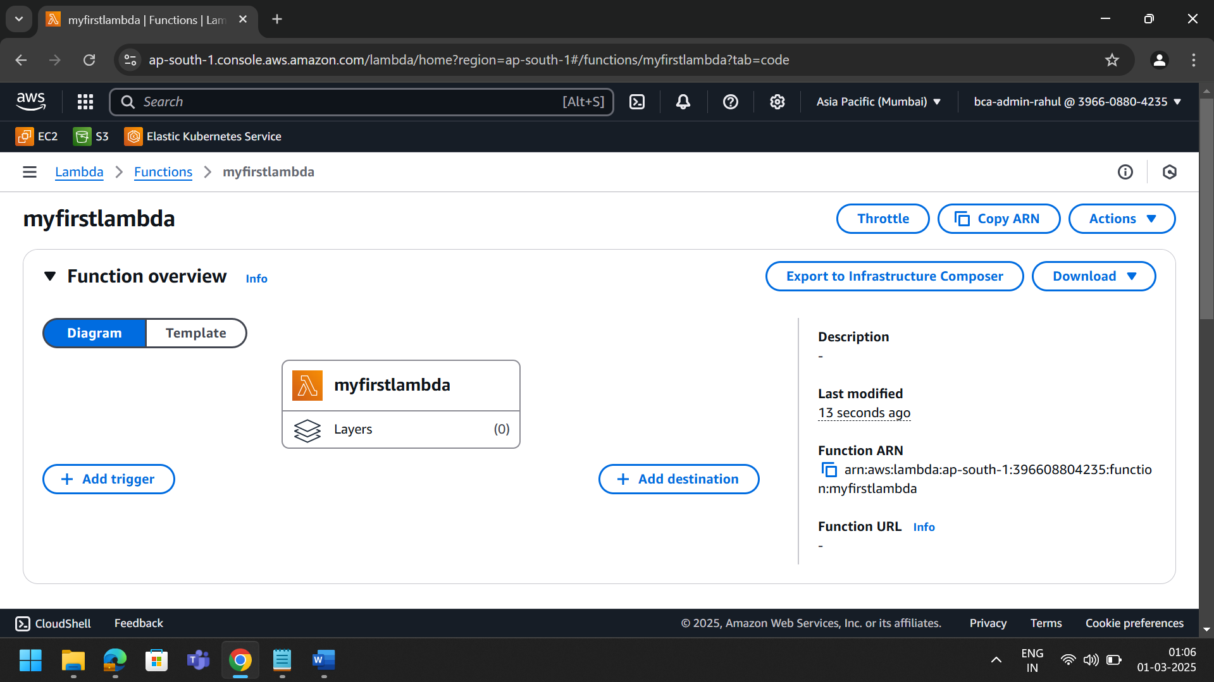

Step 2: check log group on cloud watch : no logs

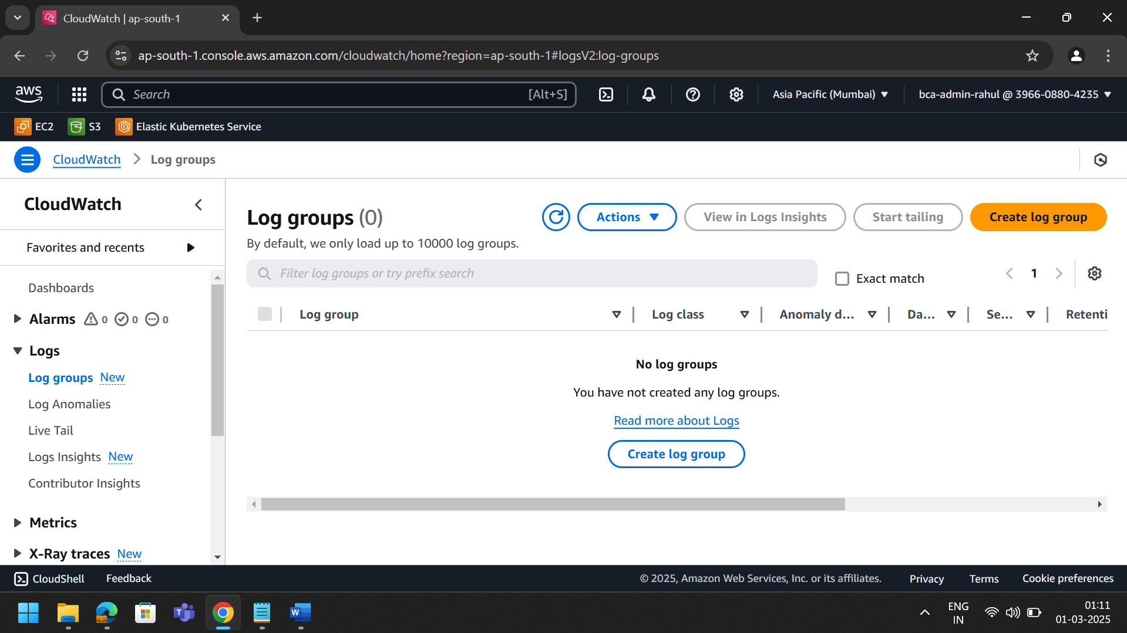

Step 3: Create jar of hello world project and upload it

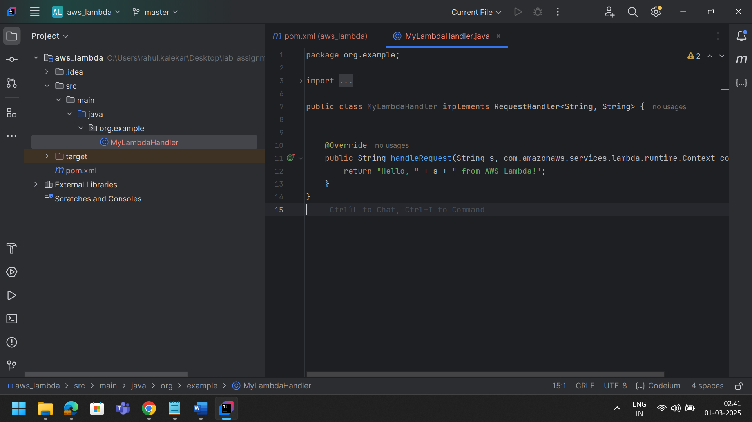

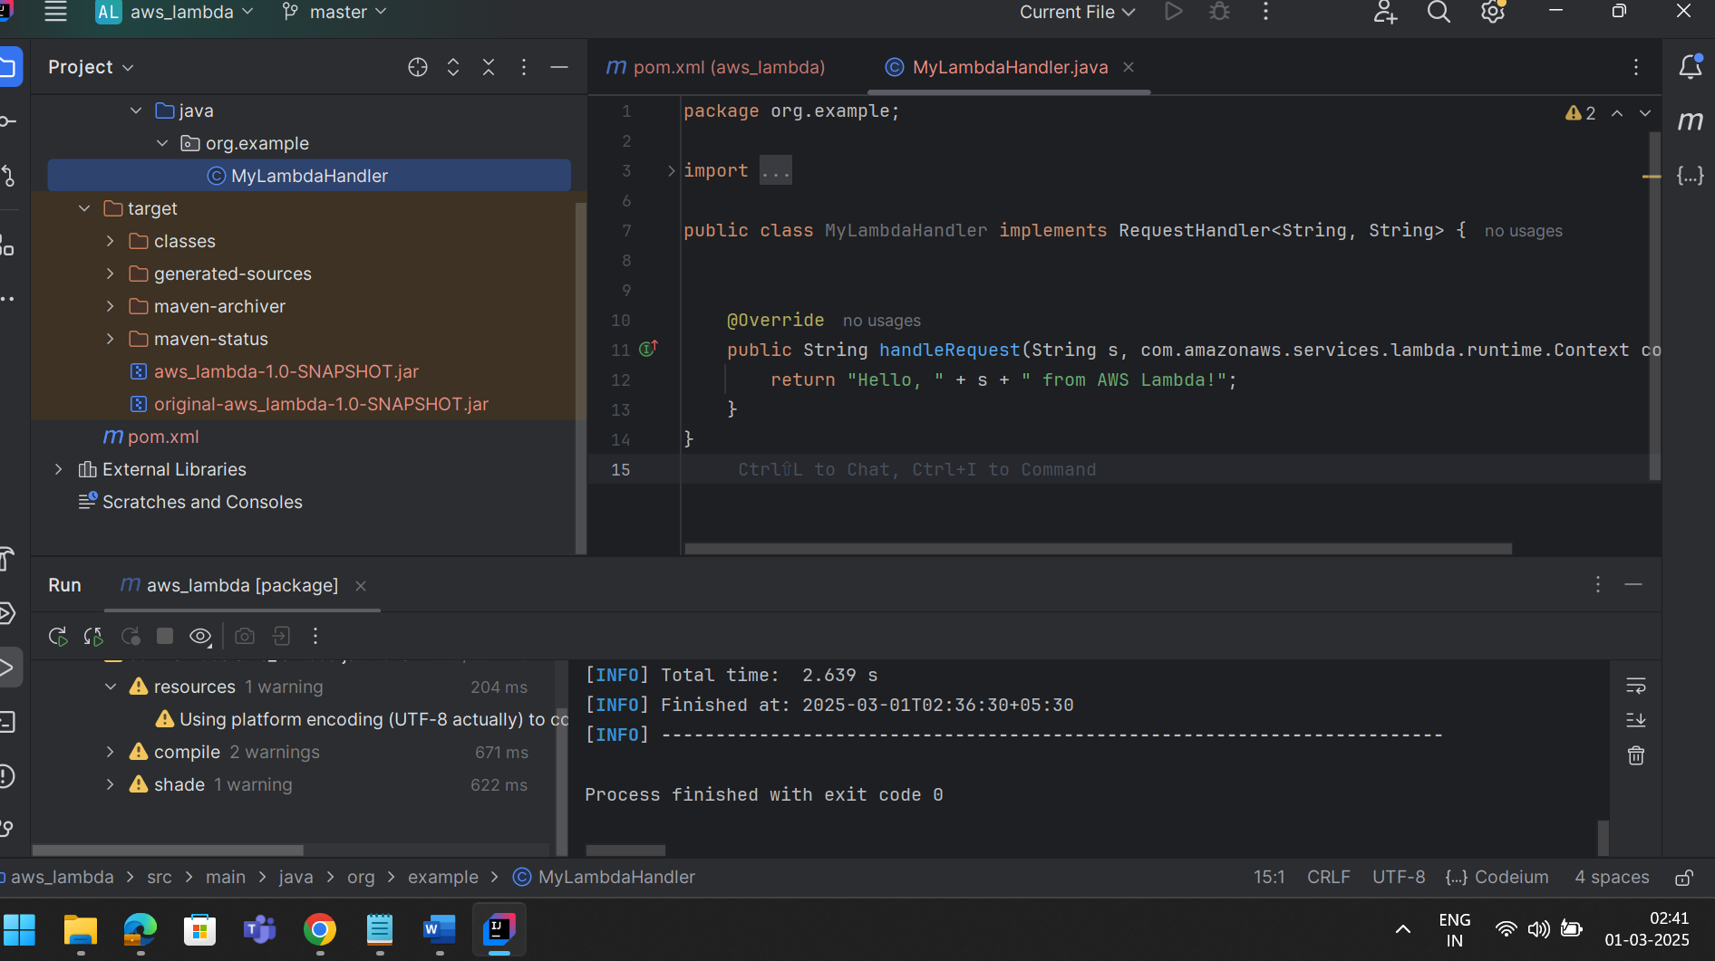

Uploading the jar file

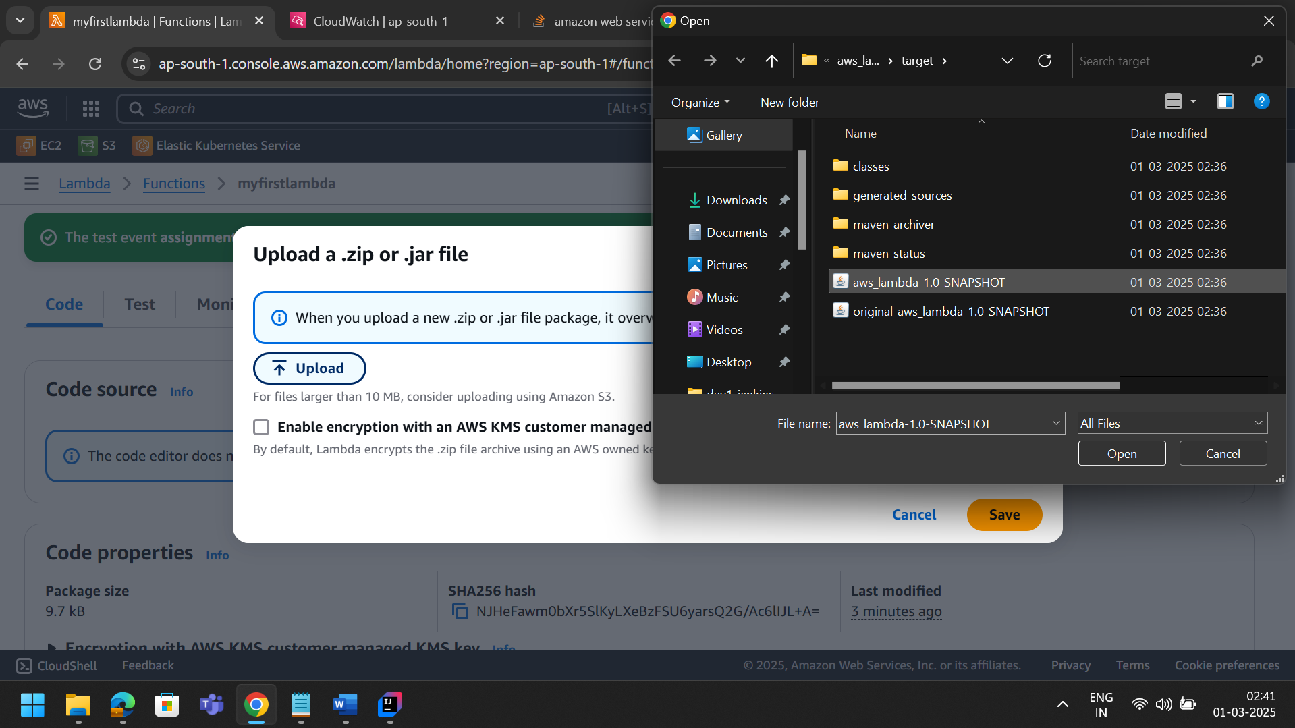

Step 4: edit runtime setting and change name of package and class and handler

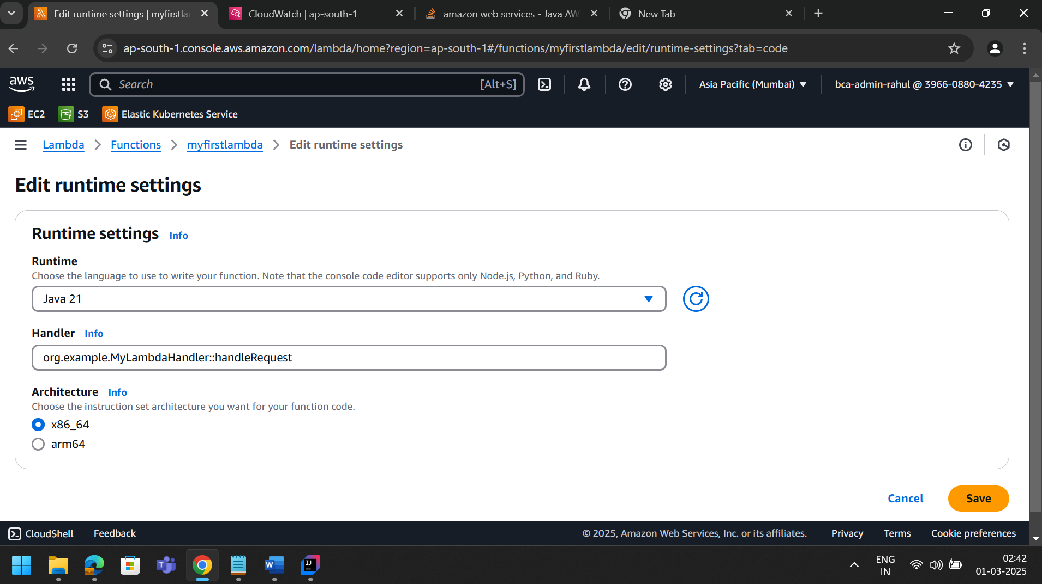

Step 5: test it

